Genetic Algorithms
Section #3
PhenoTypes & GenoTypes
Phenotype and Genotype are two terms used in Genetics. Genetics is a branch of science that deals with genes, heredity, and genetic variations. These terms are given by Wilhelm Johannsen in 1909. The concepts of Phenotype and Genotype are further included in The Genotype Conception of Heredity in 1911. The major difference between Genotype and Phenotype is that Genotype is the genetic makeup of an organism while the Phenotype is the external physical appearance of an organism.

Features | Phenotype | Genotype
Definition | The external appearance of an organism | Genetic composition of an organism
Inheritance | Not inherited from parents to offspring | Inherited from parents to offspring
Determination | Determined by observing the organism | Determined by biological methods like PCR
Effect of Environment | Affected by environmental conditions | Affected by genes
Visibility | Visible | Not visible
Appearance | Physical appearance outside the body | Genetic material inside the body
Change over time | Changes with time | Does not change with time
Relationship | It's not necessary that organisms that have the same Phenotype will also have the same Genotype | One Genotype produces only one Phenotype.

Example:-
Concept | Example
Genotype | Student ID number
Decoder | University database
Phenotype | Student information
Fitness | GPA

Genotype
The genotype is the encoded representation of a candidate solution used internally by the algorithm. It belongs to the genotype search space:
G={g1​,g2​,...,gn​}

Characteristics
Property | Description
Internal form | Used by algorithm
Manipulated by GA | Yes
Human readable | Not required
Subject to mutation | Yes
Subject to crossover | Yes

Example:-
Genotype = 101101 (This is only information encoding — not the real solution.)

Phenotype

Definition
The phenotype is the decoded and interpretable solution derived from the genotype.
It exists in the problem domain.
P=decode(G)

Characteristics
Property | Description
Real solution | Yes
Evaluated by fitness | Yes
Manipulated directly | No
Meaningful to problem | Yes

Example
Genotype: 101101
Phenotype: x = 45
Fitness: f(45)

Types of Genotype Encoding

Binary Encoding (Classic GA)
Most traditional representation.
Genotype
10110
Phenotype conversion
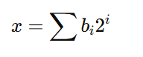
Example:
10110₂ = 22₁₀

Integer Encoding
Used in scheduling and ordering problems.
Genotype:
[3,1,4,2]
Phenotype:
visit order of cities
How to Convert Between Genotype and Phenotype?
- Binary → Real Value Conversion
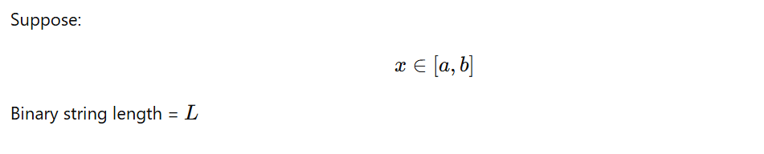



Example
Binary:
GenoType = 10110

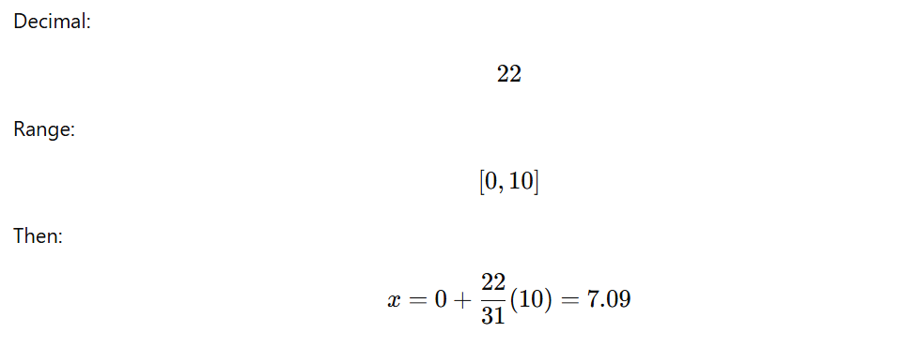
Phenotype = 7.09

- Real → Binary (Encoding)
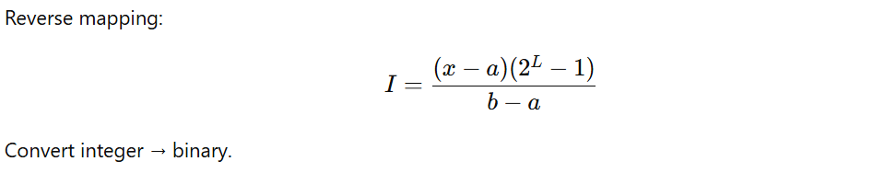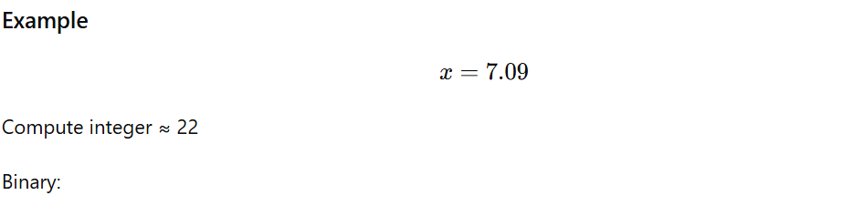
10110

